PROJECT 7: FASHIONSTORE DATA MODEL - SQL ARCHITECTURE
1. Introduction
This project aims to design a comprehensive relational database schema for an online clothing retail company. The goal is to model all critical business operations such as inventory control, sales, customer management, supplier interactions, and order fulfillment. This database model will serve as the foundation for future business intelligence tools and reporting dashboards.
2. Database Description
The database is structured to support key functional areas:
- Products and Inventory: Each product includes category, stock tracking,
- Sales and Orders: Orders are linked to customers, products, returns and payments.
- Customers: Includes personal details, shipping addresses, and optional feedback.
- Suppliers and Purchases: Enables tracking of supply chain and purchase orders.
- Admin Module: User roles and audit logs can be added if required.
3. Tools Used
- dbdiagram.io: To visualize and generate the Entity Relationship Diagram (ERD)
- SQL (PostgreSQL dialect): For schema definition and data creation
- PlantUML Live Editor: UML sequence diagrams (Sales Flow)

4. Development
a. ERD Code for dbdiagram.io
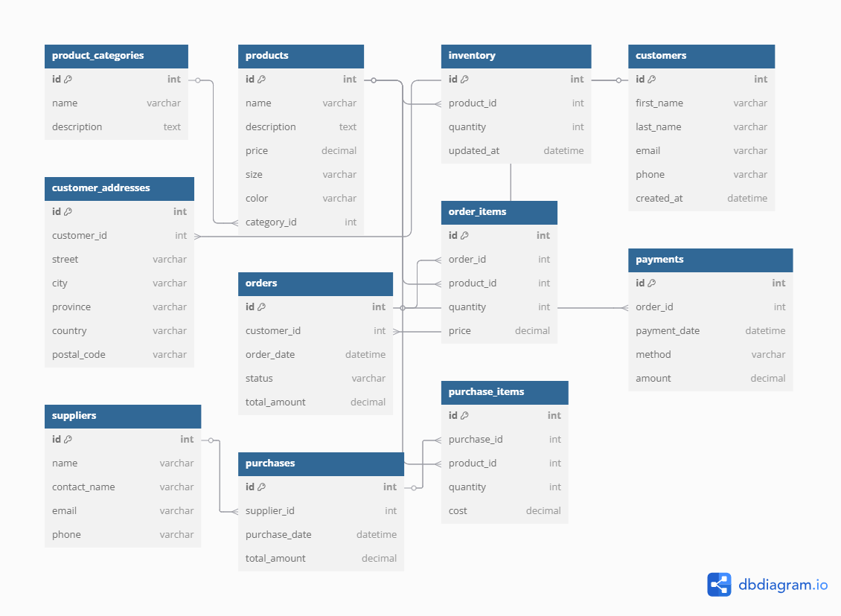
b. SQL Code for Table Creation (PostgreSQL style)
CREATE TABLE product_categories (
id SERIAL PRIMARY KEY,
name VARCHAR(100),
description TEXT
);

CREATE TABLE products (
id SERIAL PRIMARY KEY,
name VARCHAR(100),
description TEXT,
price DECIMAL(10, 2),
size VARCHAR(10),
color VARCHAR(30),
category_id INT REFERENCES product_categories(id)
);

CREATE TABLE inventory (
id SERIAL PRIMARY KEY,
product_id INT REFERENCES products(id),
quantity INT,
updated_at TIMESTAMP DEFAULT CURRENT_TIMESTAMP
);

CREATE TABLE customers (
id SERIAL PRIMARY KEY,
first_name VARCHAR(50),
last_name VARCHAR(50),
email VARCHAR(100),
phone VARCHAR(20),
created_at TIMESTAMP DEFAULT CURRENT_TIMESTAMP
);

CREATE TABLE customer_addresses (
id SERIAL PRIMARY KEY,
customer_id INT REFERENCES customers(id),
street VARCHAR(100),
city VARCHAR(50),
province VARCHAR(50),
country VARCHAR(50),
postal_code VARCHAR(20)
);

CREATE TABLE orders (
id SERIAL PRIMARY KEY,
customer_id INT REFERENCES customers(id),
order_date TIMESTAMP DEFAULT CURRENT_TIMESTAMP,
status VARCHAR(20),
total_amount DECIMAL(10, 2)
);

CREATE TABLE order_items (
id SERIAL PRIMARY KEY,
order_id INT REFERENCES orders(id),
product_id INT REFERENCES products(id),
quantity INT,
price DECIMAL(10, 2)
);

CREATE TABLE payments (
id SERIAL PRIMARY KEY,
order_id INT REFERENCES orders(id),
payment_date TIMESTAMP DEFAULT CURRENT_TIMESTAMP,
method VARCHAR(50),
amount DECIMAL(10, 2)
);

CREATE TABLE suppliers (
id SERIAL PRIMARY KEY,
name VARCHAR(100),
contact_name VARCHAR(100),
email VARCHAR(100),
phone VARCHAR(20)
);

CREATE TABLE purchases (
id SERIAL PRIMARY KEY,
supplier_id INT REFERENCES suppliers(id),
purchase_date TIMESTAMP DEFAULT CURRENT_TIMESTAMP,
total_amount DECIMAL(10, 2)
);

CREATE TABLE purchase_items (
id SERIAL PRIMARY KEY,
purchase_id INT REFERENCES purchases(id),
product_id INT REFERENCES products(id),
quantity INT,
cost DECIMAL(10, 2)
);

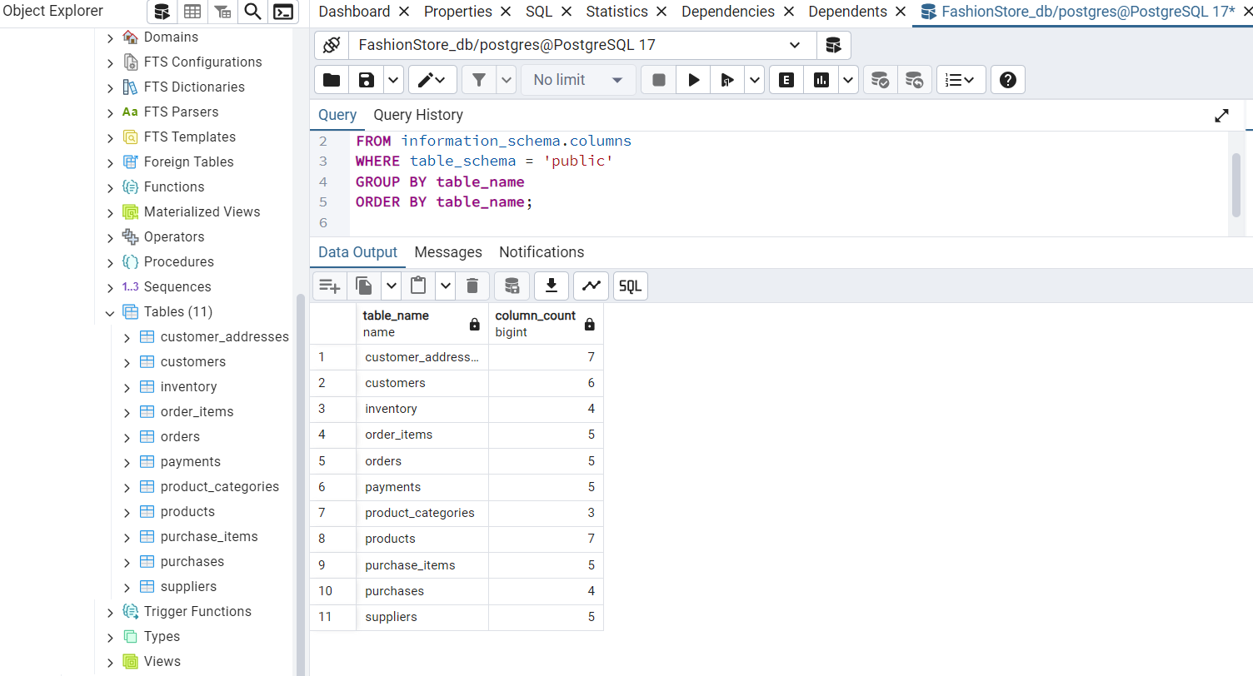

c. UML sequence diagrams (Sales Flow)
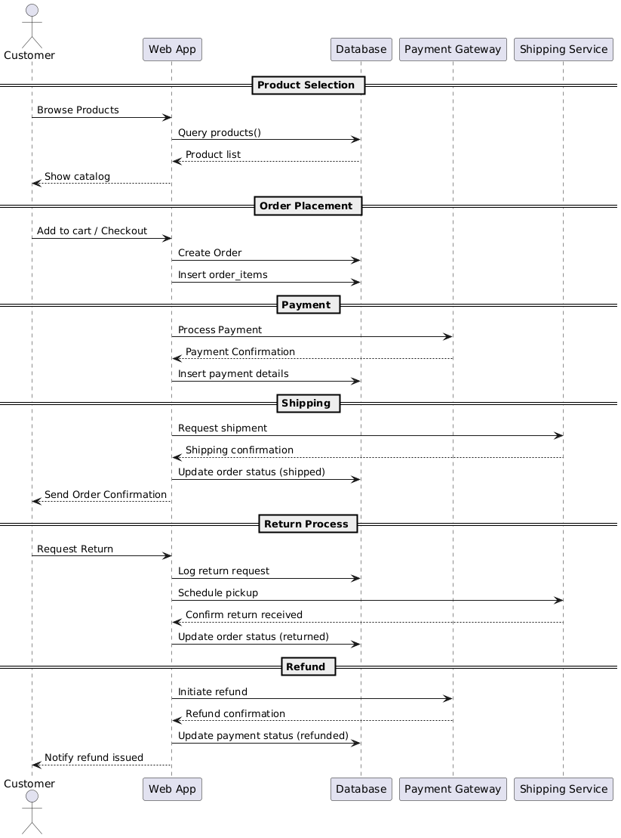

5. Results and Conclusions
This project successfully implements a robust SQL data model that reflects the complete operational flow of an online clothing retail business. It includes key functionalities such as:

Product and inventory management
Customer and order processing
Vendor and purchasing tracking
Payment and shipping coordination

The model was extended to incorporate a returns and refund process, ensuring that the database structure is compatible with real-world retail operations. This returns workflow includes:

Recording customer return requests
Integration with shipping services to schedule pickups
Updating order statuses to reflect returned items
Triggering refunds through external payment gateways
Transparency through customer notifications

The sequence diagram incorporated into this project documents the entire sales and returns process from start to finish, facilitating the interaction of each component of the system.

This schema is standardized, scalable, and ready to integrate with:
ETL pipelines for continuous data ingestion
Business intelligence dashboards with tools like Power BI or Tableau
README

FashionStore Data Model – SQL Architecture
This project designs and implements a comprehensive relational database for an **online clothing retail company**, supporting essential business processes like inventory management, customer tracking, sales processing, supplier management, and order fulfillment.

Project Overview
The goal of this project is to create a normalized and scalable SQL schema that reflects real-world retail operations. The database serves as a foundation for integrating analytics tools like Power BI or Tableau to support data-driven decision-making.

Database Structure

Core Modules:
- **Products and Inventory**
- Product catalog with size, color, and stock tracking
- Product categories and last update time

Sales and Orders**
- Customer orders, itemized order details, and payment records

Customers**
- Customer profiles and address management

Suppliers and Purchases**
- Supplier records, purchase orders, and received inventory

Extensions:
- Admin users and roles
- Product images and variants
- Customer reviews and wishlists
- Return and refund tracking

Tools Used

- **dbdiagram.io** – ERD visualization and schema design
- **PostgreSQL** – SQL code implementation
- **Power BI / Tableau (optional)** – Data visualization and BI dashboards

Development

eRD
You can view or edit the database schema visually on [dbdiagram.io](https://dbdiagram.io) by importing the ERD definition.

SQL Schema
All tables were created using PostgreSQL syntax. Core tables include:

- `product_categories`
- `products`
- `inventory`
- `customers`
- `customer_addresses`
- `orders`
- `order_items`
- `payments`
- `suppliers`
- `purchases`
- `purchase_items`

Each table uses appropriate foreign key relationships to maintain data integrity.

Results and Conclusions

This project successfully implements a robust SQL data model for a digital retail environment. The structure:

- Covers end-to-end retail processes (sales, supply, inventory, customer management)
- It is designed for future scalability and integration
- Enables data warehousing and business intelligence use cases
The model was extended to incorporate a returns and refund process, ensuring that the database structure is compatible with real-world retail operations. This returns workflow includes:

> Future work could include integration with Python-based ETL pipelines, machine learning for sales forecasting, or customer segmentation analytics.

Project Structure
├── README.md
├── Code_create_tables_sql_sample.txt # SQL
├──Relation_tables_foreign_keys.csv (export SQL)
└── ERD.pgerd # ERD model file (.png export)
├──UMLSalesFlow.png

Author
Monica Prieto — Data Engineer

